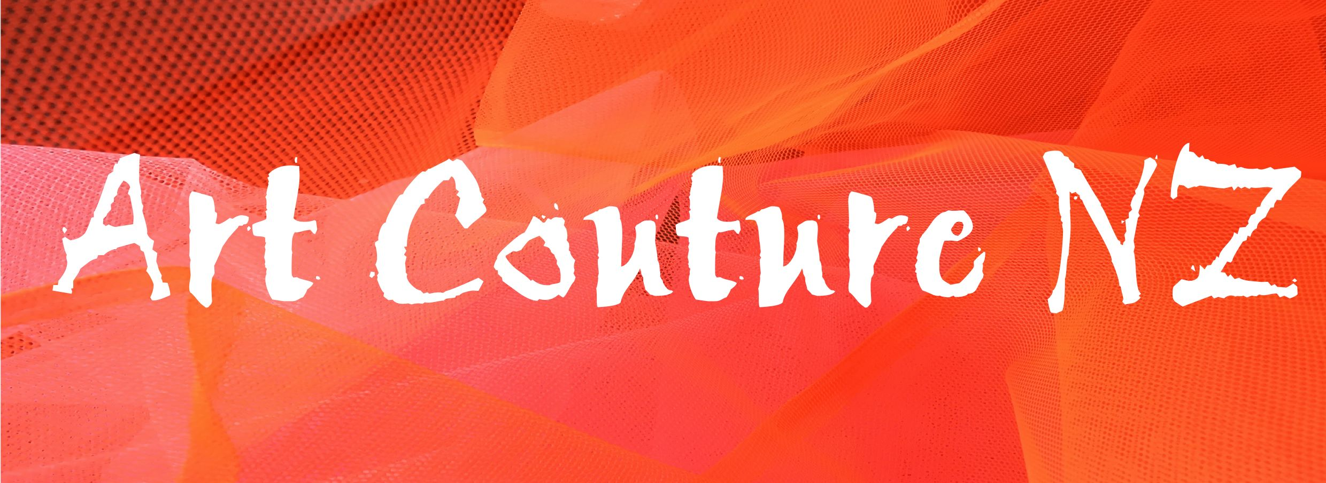

Entry form 2018
One entry form per garment please
Name (s)_______________________________________________________________________________________
Address_____________________________________________________________________________________________________________________________________Postcode____________________
Email__________________________________
Telephone ______________________________

Section (tick)
Student (under 20yrs) (under 13yrs)
√

Comment regarding parental help_________________________________________________________________
Adult Category Open Here we go again Hardware Sow’s Ear
√
√
√
√
Designer(s)/creator’s_____________________________________________________________________________
Models Name___________________________________________________________________________________
Artworks Name__________________________________________________________________________________
Materials used___________________________________________________________________________________
Comments for the programme. Max 200 words.
_____________________________________________________________________________________________________________________________________________________________________________________________________________________________________________________________________________________________
Entry is via email to artcouturenz@gmail.com
Fees: Under 20's $30 per garment
Adult- $50 per garment
√
Subsidised Professional model $50
Art Couture Sow’s Ear $120 (includes materials required)

Amount $…………… to be paid to BNZ Art Couture NZ 02 0810 0097510 000

Drinks and nibbles will be provided in the dressing room. Designers and models are welcome to sit on the bleachers to watch the show at no charge. Upgraded tickets will be available at a cheaper price for a limited time through Dash Tickets.

I have read the rules of Entry and accept these conditions
Entrant(s) Signature(s)__________________________________________________________

